**Community Safety Project Proposal**

Participation in positive activity opportunities changes lives and communities for the better. Research proves that said communities are not only healthier and more active but are also safer and stronger as a result.

This project vision is to; increase the positive activity offer available to young people in their local area, with a specific emphasis on early interventions and diverting young people away from anti-social behaviour and crime.

The project aims to:

* Strategically link to the council’s corporate plan, youth insight data and consultation on the needs of young people locally.
* Work in partnership with other organisations to maximise the local offer of activities.
* Have qualified and appropriate staff in enabling and delivering the activity offer.
* Offer opportunities for sustainability, engaging with local providers and young people in its design and implementation.
* Be accessible to all, adopting a prevention model, whilst also providing opportunities to work with more targeted individuals and groups through intervention work.
* Ensure the provision and enabling of quality, empowering, fun and low cost activity in a safe environment, which encourage lifelong behavioural change.

The project will initially focus on five main objectives

* Create a strategic programme of high quality, low cost positive activity and youth sessions, delivered in hotspot areas during the holidays, summer months and evening times.
* Work with key partners and community groups to create an integrated intervention programme of positive activity sessions that will complement a wider range of support services provided by partner agencies. These will be targeted at young people who may be at risk of offending or causing anti-social behaviour.
* Identify, promote and develop safe spaces where young people can engage in positive activities independently or with friends and family.
* Provide support to local groups and individuals that want to create new opportunities for young people to engage in positive activity.
* Establish a South Ribble Leadership and Volunteering Academy that will recruit and train local young people aged 16-24 yrs. to be able to assist in the delivery of activities for young people across the borough.

Each area of work will establish its own set of outcomes and performance indicators. They will however be designed to contributing towards the following core outcomes

* Targeting local ‘hotspots’ with attractive and positive activities for young people
* Provide young people with coping strategies so that they are more resilient and better able to resist pressure to take part in harmful or anti-social behaviour
* Increasing young people’s self-esteem, organisational and social skills
* Providing positive role models for young people through the staff and local organisers leading the activities
* Decreasing the perception and fear of crime and anti-social behaviour amongst the local community
* Providing employment and volunteering opportunities either directly through qualifications e.g. Coaching, young leaders or volunteering opportunities
* Empowering local individuals and community groups to be able to provide sustainable ongoing activities

**Partner Agencies**: The success and sustainability of this project will be based upon the partnerships built. We aim to work closely with the following statutory and voluntary sector agencies. Lancashire Police, Lancashire County Council Intervention Services. Youth Services, Mental Health Support Services, Age Concern, Lancashire FA, Active Lancashire, Sport England street games, local Parish Councils, Uniform groups , Primary and Secondary Schools , Runshaw College, South Ribble Partnership and local clubs

**Examples of some possible programme ideas:**

[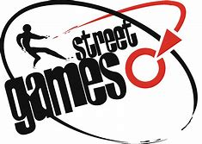](https://www.bing.com/images/search?view=detailV2&ccid=UhOuyFGr&id=BE96C19A85500C3E50D897D6285895D668522964&thid=OIP.UhOuyFGr9kHJnDmDNX9DlAHaFR&mediaurl=https://www.activatefun.co.uk/media/1093/streetgames-logo.png&exph=1342&expw=1887&q=street+games+&simid=608002785084113593&selectedIndex=1)Street Games are a national charity who have created range of successful project models that harnesses the power of sport and activity to create positive change. This project would enable the sports/community development team to work in partnership with the organisation to deliver some of their programmes.

[](https://www.bing.com/images/search?q=images+fit+and+fed&id=062960D8AB814845DDF0D4BC57385A965C588597&FORM=IQFRBA) For example we could enhance the council’s holiday hunger programme by offering some fit and fed clubs. These are affordable holiday programmes where young people take part in activities, socialise and learn new skills whilst also receiving a healthy meal.

We could also adopt their Door Step Sport model by providing a range of Doorstep Sport Clubs. These are informal sports/community clubs that operate at the right time, place, price point and in the right style to suit the needs of disadvantaged young people. Doorstep Sport Club’s provide a vibrant and varied sporting offer to these young people, designed to increase their motivation, and to help them develop a sporting habit for life.

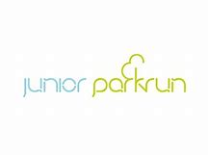Opportunities would also be available for us to utilise further our Parks and Green Spaces through the establishment of a Junior Park Run. These are weekly volunteer led 2k runs for young people.

[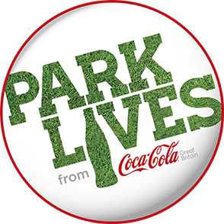](https://www.parklives.com/)Park Lives is another example of a national programme which could be delivered, It aims to give 8 -25 year olds and their families, opportunity to access parks within their local communities, through engagement in a variety of wellbeing activities run over a 16-20 week period. Young people will be exposed to a broad offer of sports and activities providing them with the skills, knowledge and confidence to access local parks in their community.

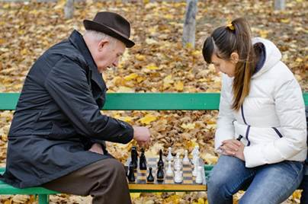 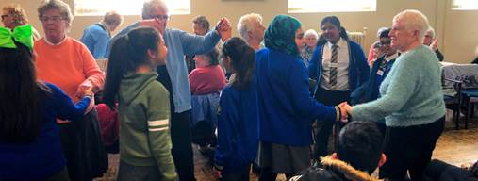

Intergenerational projects such as tea dances and games evening’s, can contribute to the outcomes set. Providing opportunities for young and old to interact and share skills can help to promote a greater respect and understanding between generations.